CURRICULUM NEWSLETTER
INGLETON C OF E PRIMARY

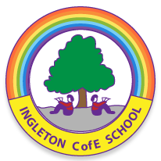

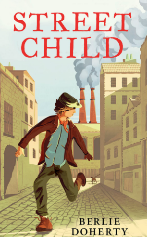
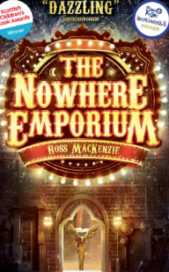

Spring Term 1 2026

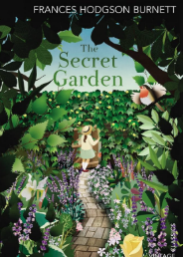
Oak Class
This half term, in Oak Class, we will be learning about …

Geography
In Geography this half term, our unit is called Mapping, Measuring, Making and Managing Mountains. Pupils will begin by mapping the location of mountains around the world, before exploring how mountains are made and measured. We will introduce contours and practise reading them to understand mountain shapes and heights. Later in the unit, we will focus on how mountains are managed, including looking at the challenges they face, such as avalanches, and the strategies used to keep people and the environment safe. This unit will help pupils develop map skills, measurement techniques, and an understanding of human and physical geography.
DT
In DT this half term, we will be designing and building mechanical cars. Pupils will start by creating three different prototypes: an inclined plane car, a slingshot car, and a wind-up car, exploring how each design moves. Next, we will move on to a mechanical toy car kit, where pupils will plan their own designs before making and testing their cars. Finally, they will evaluate their creations, thinking about how to improve their designs and understanding how mechanical systems work in real-life vehicles.

COMPUTING
In Computing this half term, we will be finishing our Spreadsheets unit and starting our new unit on Computer Coding. Pupils will learn how to code efficiently and simulate physical systems, exploring concepts like friction and functions. We will also be introduced to strings, text variables, and concatenation, and practise using user input to make our programs interactive. This unit will help pupils develop logical thinking, problem-solving skills, and creativity in coding.
.

Science
In Science this half term, our unit is Looking After the Environment. Pupils will explore what climate change is, what causes it, and how it affects the planet. They will investigate the actions that people, organisations, and governments are taking to protect the environment and develop their skills in Working Scientifically. The lessons build on previous learning from Year 3 and Year 4, helping children recall and apply their knowledge while thinking critically about real-world issues. This unit also links to exciting career opportunities, showing how science can connect to future jobs and local industries, inspiring pupils to think about how they can make a difference for the planet.
RE
n RE this half term, we will be exploring the question: “What difference does the Resurrection make for Christians?” Pupils will learn about the significance of Jesus’ Resurrection and how it influences Christian beliefs, practices, and celebrations. We will discuss its impact on hope, faith, and the way Christians live their lives today, encouraging thoughtful reflection and meaningful discussion.
MFL
In French this half term, we will be completing our Clothes unit. Pupils will start by learning to name different items of clothing, then use adjectives of colour to describe what people are wearing. We will explore parts of the verb to wear in French and practise describing full outfits, including colours, especially for school. Later in the unit, we will focus on carnival outfits, learning the related vocabulary and understanding descriptions of these festive costumes. This unit will help pupils build confidence in talking about clothes and expressing themselves in French.

English
This half term in English, we have lots of exciting learning ahead! We will be writing our own newspaper reports based on the story of Goldilocks, thinking carefully about headlines, quotes and formal language. We will also be creating a narrative mystery inspired by The Nowhere Emporium, focusing on suspense and atmosphere. In reading, we will continue developing our skills through Comprehension Ninja, practising key strategies to deepen our understanding of texts. Our whole-class reading books this half term will be Street Child and The Secret Garden, where we will explore rich vocabulary, character development and important themes. We’re looking forward to a fantastic half term of reading and writing!
Maths
In Maths, we will be continuing our learning on fractions, decimals and percentages, as well as developing our understanding of area, perimeter and volume. We will also be exploring angles, translations and coordinates, building our problem-solving and reasoning skills across all topics. We’re looking forward to another busy and exciting half term!
Music
In Music this half term, pupils will be exploring how musical elements can be used to represent landscapes, with a particular focus on mountains. They will learn and apply key vocabulary such as tempo, dynamics, pitch, texture and structure, developing their understanding of how composers create a sense of height, vastness and movement in their work. The children will listen to examples, discuss how the music paints a picture, and experiment with different composition techniques to create their own musical representations of mountains.




www.ingletoncofeprimary.co.uk
admin@ingletoncofeprimary.co.uk
01325 730366

