CURRICULUM NEWSLETTER

INGLETON C OF E PRIMARY



admin@ingletoncofeprimary.co.uk

www.ingletoncofeprimary.co.uk

01325 730366

Autumn Term 1 2025

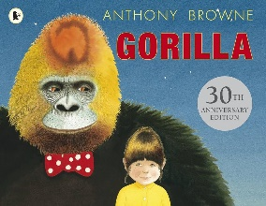

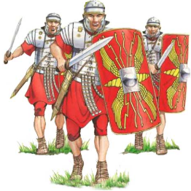

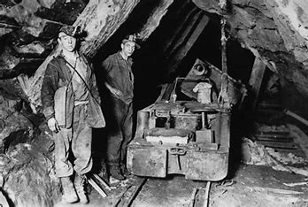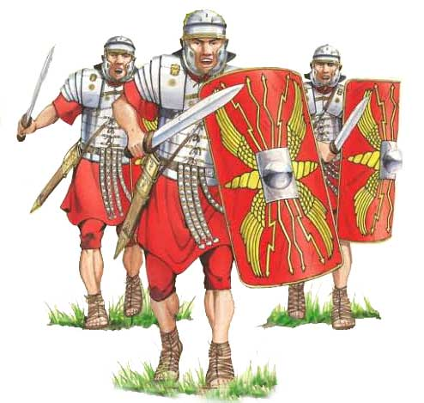

|  |
| --- |
| Oak Class |
|  |
| This half term, in Oak Class, we will be learning about … |

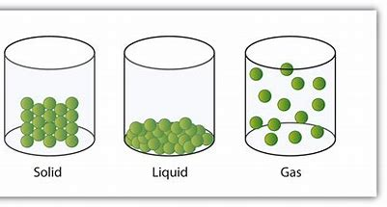

|  |
| --- |
| History |
|  |
| In History, we will be studying the Romans in Britain, exploring how the Romans invaded and transformed British society. We’ll learn about the Roman way of life, including their roads, baths, and towns, and how their presence shaped Britain’s development. A key focus will be Boudicca’s Rebellion, where students will investigate the causes, events and outcome of the revolt led by the fierce queen of the Iceni tribe. This topic will help students understand the complexities of Roman rule and its lasting impact on Britain.  Art and Design  In Art, Year 5 and 6 will be completing a unit on drawing and shading, where they will learn to draw like an artist by using shapes as the foundation for their artwork. Children will explore how to break down objects into simple shapes and then add depth and dimension through shading techniques. They’ll practice light and shadow to create more realistic and textured drawings, developing their skills in observation and technique. |

PE

In PE, the children will be swimming at Teesdale Leisure Centre on Tuesdays, where they’ll work on their swimming skills and water safety. On Thursdays, they’ll focus on basketball, learning new skills such as dribbling, shooting, and teamwork while enjoying friendly games and challenges.

COMPUTING

In Computing, children will be learning how to create their own quizzes on Purple Mash and thinking about how to stay safe online.



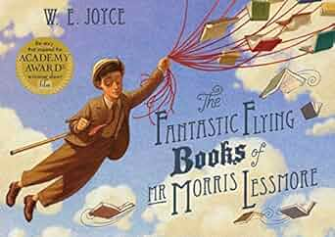

|  |
| --- |
| English |
|  |
| This term in English, Year 5 and 6 students will be diving into two exciting writing projects! They’ll explore the imaginative world of *Gorilla* by Anthony Browne, using the story to inspire their own fictional writing. Later, they’ll research and write a biography about the incredible life of Sir David Attenborough, learning how to structure non-fiction while celebrating his contributions to nature and the environment. It’s going to be a term full of creativity and learning!  Maths  In Maths this term, Oak Class children will focus on mastering place value and deepening their understanding of the four operations—addition, subtraction, multiplication and division. They’ll develop their skills through hands-on activities and problem-solving challenges, building a strong foundation for more advanced maths concepts!  Music  We will be learning to play the glockenspiel focussing on a South African influence on the musical instrument. |
|  |

|  |
| --- |
| Science |
|  |
| In Science, Oak Class will explore a range of exciting topics in the *Properties of Materials* unit. They will investigate how materials react in different conditions, starting with burning and the chemical reaction between acids and bicarbonate of soda. Students will also learn about dissolving mixtures, changes of state, and how materials can be separated by filtration, sieving and evaporation. They’ll experiment with the hardness of materials, explore transparency and understand the properties of thermal and electrical conductivity.  RE  In RE, Oak Class will explore the question: *Creation and Science: Conflicting or Complementary?* Students will look at different beliefs about how the world was created, comparing religious creation stories with scientific theories such as the Big Bang and evolution.  MFL  In French, Year 5 and 6 will explore *"Me and My Friends"*, learning to describe feelings using adjectives and answer questions like "How are you?" in more detail. They’ll also talk about themselves and their friends and give opinions on school subjects, saying whether they like or dislike them.  . |