CURRICULUM NEWSLETTER
INGLETON C OF E PRIMARY

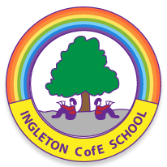

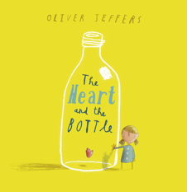
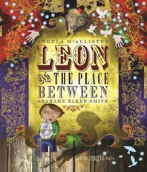
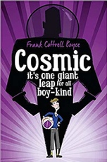




admin@ingletoncofeprimary.co.uk
www.ingletoncofeprimary.co.uk
01325 730366
Autumn Term 1 2026

Chestnut Class
This half term, in Chestnut Class, we will be learning about …

Art
In Art this half term, we will be exploring painting and mixed media through portraits. We will look at self-portraits created by a range of different artists and explore the techniques and styles they have used. Using photographs of ourselves as a starting point, we will then develop our own unique self-portraits, experimenting with different materials and mixed media to create something that reflects our own individual style.

History
In History this half term, we will be learning about the Anglo-Saxons and Viking invasion and settlement in Britain. We will explore why the Vikings came to Britain, what life was like for the people who lived here and how their arrival changed the country. We will develop our understanding of cause and consequence and use a range of historical evidence to investigate events and decide what we think happened in the past.

DT
In DT this half term, we will be exploring Cooking and Nutrition, with a focus on adapting recipes. We will start by learning how to make a basic biscuit recipe before thinking about how we could change and adapt it for a particular audience. We will also consider the cost of ingredients and other expenses, working within a set budget to make sure our ideas are both tasty and affordable. There will be plenty of opportunities to get creative and put our cooking skills to the test!

PE
Our PE lessons will

Science
In Science this half term, we will be learning about Animals Including Humans. They will explore the different types of teeth in humans and other animals, investigate the functions of the digestive system and learn how food is broken down and transported around the body. We will also study Living Things and Their Habitats, with a focus on classification and conservation. Children will learn how living things can be grouped in different ways and explore why conservation is important in helping to protect habitats and species.

RE
In RE this half term, we will be exploring what Christians learn from the Creation Story, considering what the Bible teaches about God as Creator and why Christians believe the world is a gift from God that should be cared for. We will also investigate the question “What is the Trinity and why is it important to Christians?”, learning about God as Father, Son and Holy Spirit, and exploring the Christian belief in Incarnation, where Jesus is understood to be God in human form.

MFL
In French this half term, our topic is “This is Me!” We will recap how to talk about ourselves and share personal information, as well as learning how to describe our appearance and personality. We will also explore different professions and aspirations, giving us the opportunity to talk about what we would like to do when we are older. We will continue to build our confidence in speaking, listening, reading and writing in French.

English
This half term, our writing will be inspired by the texts The Heart and the Bottle by Oliver Jeffers and Leon and the Place Between by Angela McAllister. Through these engaging stories, children will develop their narrative writing, descriptive language and dialogue skills whilst exploring themes of curiosity, imagination, emotions and wonder.
In reading, we will be enjoying Cosmic and The Explorer, building our comprehension and inference skills as we discuss characters, events and themes.
Alongside our English work, we will continue to build our SPaG knowledge, practise our handwriting techniques and focus on presenting our work neatly and to a high standard.
Maths
In Maths, we will be following the White Rose Maths scheme, starting the year by focusing on place value, before moving on to addition and subtraction. We will also have regular arithmetic lessons to build confidence and accuracy with key skills. Alongside this, we will be using TT Rockstars regularly to help us improve our times tables recall and get those multiplication facts nice and speedy!
Music
In Music this half term, we will be exploring Caribbean music, learning about the history and key features of calypso music. We will have lots of opportunities to perform, including singing and playing tuned percussion as part of a multi-part calypso-style song. We will also be developing our ability to read and play from staff notation. Alongside this, we will continue to build our confidence and skills through our instrumental lessons.

