Oak Autumn Term 2025 Challenge Homework
Please find below details of Oak class challenges. Please note the homework covers the whole Autumn term and is to be handed in by Friday 12th December. All children in KS2 must complete at least one piece of the challenge homework. Our history theme this term is: Romans in Britain and our geography topic is Greece. In Science this term we are covering Properties of Materials. Have fun completing the challenges 😊
Geography - Greece  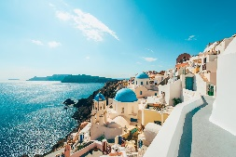  Describe the key physical features of Greece, including its mountain ranges, major rivers and surrounding seas. How do these features influence the climate and economy of the country? | Science – Properties of Materials    Describe the difference between transparent and opaque materials. Also, explain what makes certain materials magnetic and give an example of a magnetic material. Make a list of transparent and opaque materials around your home. | History – Romans in Britain  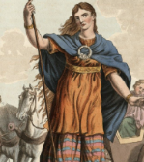  Write about why Boudica, the queen of the Iceni tribe, fought against the Romans and what happened during her big battle. Tell the story of her rebellion, how she destroyed Roman towns and why she is remembered as a brave leader today!
  Science – Properties of Materials  Define material hardness and explain how the Mohs scale is used to measure it. Choose two materials and compare their hardness levels. Show your findings on a poster. | Art – Drawing and shading  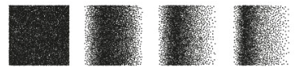  Create a botanical drawing using shading techniques like hatching, cross-hatching and stippling to add depth and texture. Focus on how light interacts with the plant to highlight its natural form and detail. | Science – Properties of Materials  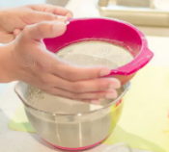  Try separating a mixture of sand and water or flour and rice. What method worked best, and why?  Make sure to show your results and explain the science behind your experiment!
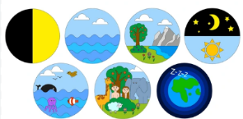  RE/Art - Creation  Choose a part of the Creation Story from Genesis 1:31 and create a picture. You might choose a picture of the Earth, Space, Sea or land. You could even create a picture of a favourite animal or be able to show all the different days. | Be Creative  Choose your own! 😉  Create your own challenge homework based on any topic we have covered or will be covering in school this term. | Computing – Quizzes    Create a quiz about yourself using Purple Mash. Include at least 10 questions about yourself and be sure to add multiple-choice answers and a fun title for your quiz.
History - Historical Timeline Creation  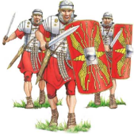  Create a poster or timeline showing key events from when the Romans came to Britain. Include important dates, people (like Julius Caesar), and what changed because of the Roman invasion. | English -    Choose a famous person and write a biography about who they are, what they’re known for and interesting facts. You can also draw a picture of them if you like! |   Get Baking  Start feeling festive by making a Christmas themed treat to eat!  29 Christmas baking projects for kids | BBC Good Food

