EYFS Optional Challenge Projects – Spring Term
If you wish to complete one or more of the activities listed below, please bring it in to share by Wednesday 9th April 2025. We can’t wait to see your ideas and creations!
Make a model boat out of materials of your choice, test it to see if it floats.  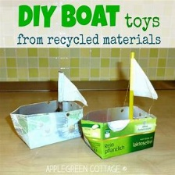 | Materials Hunt – Search around your home and find objects that are made of different materials. Can you name some of the materials?  Objects Materials | What did Mary Anning discover? Can you find out any more facts about her?  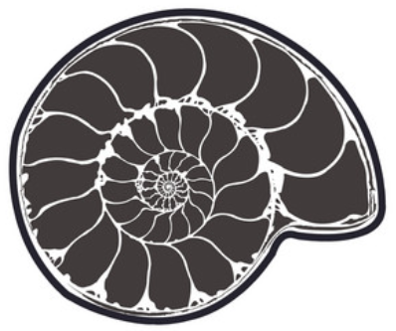 | Can you use recycled materials to make a model space craft?  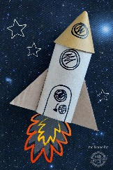
Make a weather chart to show what the spring weather is like each day. You could cut out the weather pictures to stick on a chart, or you could draw a picture of the weather each day.  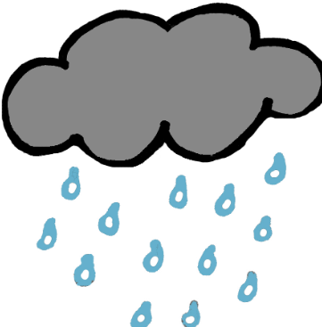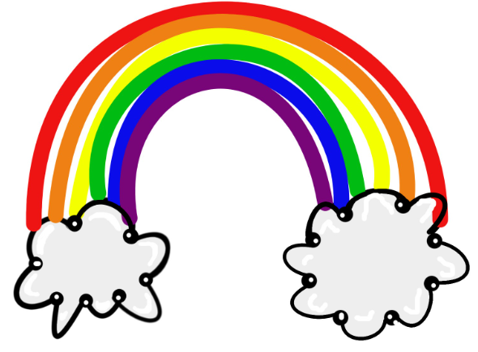 | In the spring, lots of flowers grow. Draw or paint a picture of a flower. What colours do you need? Remember to draw the stem, some leaves and some petals  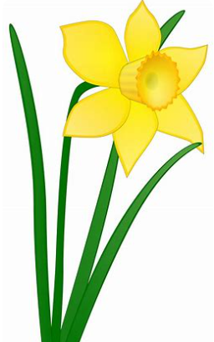 | 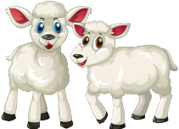  Lots of baby animals are born in the spring. Find out the names of these baby animals: duck, pig, sheep, cow and chicken. You could ask a grown-up to help you find the answers on the Internet or in a book. | Draw a simple map of your local park/playground? Include as many features as you can.  
Can you draw or list items that would be needed on a mission to space?   | Can you name any other planets? Can you draw or make a model about what we might find beyond planet Earth?  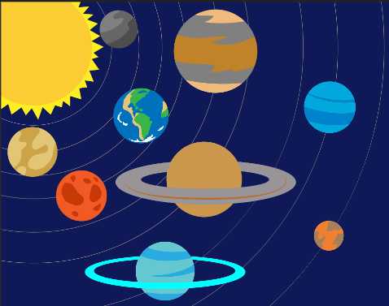 | With support from an adult, follow a simple recipe to make a dish for you and your family to share.  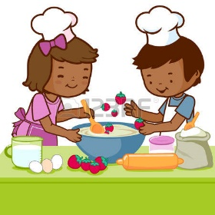 | Design a self portrait and surround it with words or pictures about your own dreams and goals.  