CURRICULUM NEWSLETTER
INGLETON C OF E PRIMARY

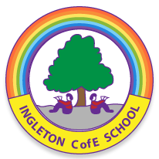

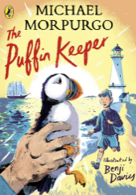

Spring Term 1 2026
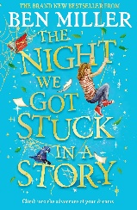
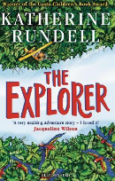
Oak Class
This half term, in Oak Class, we will be learning about …

History
In History this half term, we will be studying the Ancient Greeks. Pupils will explore Greek life, beliefs, and achievements, and discover how this remarkable civilisation has influenced the world we live in today. Through stories, artefacts, and investigations, we’ll gain a deeper understanding of what made Ancient Greece such an important period in history.

Art
In Art this half term, we are learning how to create expressive sculptures and reflect on the artistic decisions we make throughout the process. Pupils will explore how to represent memories through art, using a variety of materials and techniques to bring their ideas to life. They will also develop important skills in planning, creating, and evaluating their own 3D sculptures.

PE
n PE this half term, we will focus on dance, developing coordination, expression, and creativity through a range of movement activities. We will also be developing our skills through netball where we will have the opportunity to work with a Staindrop Academy coach to build children’s skills, teamwork, and game awareness.

COMPUTING
In Computing this half term, we will continue our “Being Safe in a Digital World” lessons, learning how to protect ourselves and make responsible choices online. We will also explore digital graphing and spreadsheets, developing skills to collect, organise, and interpret data effectively.

English
In Writing this half term, we will be working on The Explorer as our adventure narrative unit and exploring Moth through poetry, developing rich language and creative storytelling skills. In Reading, we will continue using Comprehension Ninja, CGP, Testbase, and Literacy Shed to strengthen our understanding and inference skills. Our Story Time text will be The Night we got Stuck in a Story, giving us a wonderful mix of humour, adventure, and heartwarming storytelling to enjoy together.
Maths
In Maths this half term, we are continuing to build our confidence with long and short multiplication and division, as well as multiplying and dividing fractions. We will also be working on rounding decimals to three decimal places and exploring area, volume, and capacity. These topics will help strengthen our problem-solving skills and deepen our understanding of how maths is used in real-life situations.
Music
In Music this half term, we will be learning all about musical theatre. Pupils will explore what musical theatre is and be able to recall at least three key features of this exciting style of performance. They will learn how to categorise songs as either action songs or character songs and will choose appropriate existing music to accompany a scene that tells the story of a journey. Pupils will also work on performing confidently in groups, making smooth transitions between spoken dialogue, singing, and dancing to bring their scenes to life.

Science
In Science this half term, we will be learning about microorganisms, exploring the different types and how they can be both helpful and harmful. We will also be studying classification, discovering how living things are grouped based on their characteristics and why this system is important for scientists.
RE
In RE this half term, we will be exploring the question “What does it mean if Christians believe God is holy and loving?” We will look at how these beliefs shape the way Christians understand God and how they influence the choices Christians make in their daily lives. Through stories, discussion, and reflection, pupils will gain a deeper understanding of these key Christian ideas.
MFL
In French this half term, we will be working on our “At the Market” unit. Pupils will begin by learning to name a range of fruits and vegetables and then take part in a class survey about favourite choices. We will also learn to count in tens up to 100 in French. As the unit continues, pupils will practise asking for and giving prices of items at a market and take part in a simple shopping dialogue. We will finish the unit by exploring a French recipe, using and understanding simple cooking instructions.




www.ingletoncofeprimary.co.uk
admin@ingletoncofeprimary.co.uk
01325 730366

