CURRICULUM NEWSLETTER
INGLETON C OF E PRIMARY

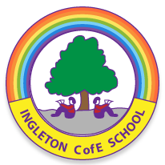

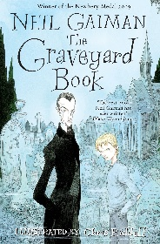




admin@ingletoncofeprimary.co.uk
www.ingletoncofeprimary.co.uk
01325 730366
Autumn Term 2 2025
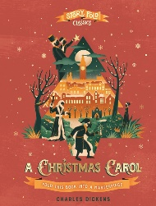
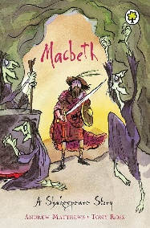
Oak Class
This half term, in Oak Class, we will be learning about …

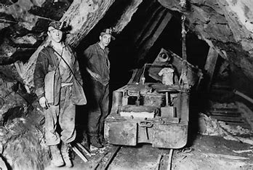
Geography
In Geography this half term, we will be exploring tourism in Greece. Our studies will focus on location and place, examining where key tourist destinations are and what makes them special. We will also look at change, understanding how tourism has developed over time, and cause and effect, exploring the impacts of tourism on the environment, local communities, and economy.

Design and Technology
In DT this half term, we will be working on our Digital World: Mindful Moments Timer project. We will explore the concept of mindfulness and learn how to write design criteria to develop a programmed product that can time a mindful moment. This project will help us combine creativity, coding, and thoughtful design to create a practical and calming tool.

PE
In PE this half term, we will be taking part in gymnastics and swimming. In gymnastics, we will focus on developing strength, balance, and coordination through a variety of movements and routines. In swimming, we will work on improving our technique, stamina, and confidence in the water.

COMPUTING
In Computing this half term, we will be using Purple Mash to create our own games and explore graphing. This will give us the opportunity to develop our coding and problem-solving skills, while also learning how to collect, interpret, and present data effectively.

Science
In Science this half term, we will be exploring the properties of materials through a series of exciting investigations. We’ll look at Separation by Evaporation, Hardness, Transparency and Magnetism, and Thermal and Electrical Conductivity. These lessons will help us understand how different materials behave and why they are used for specific purposes in everyday life

RE
In RE this half term, we will be exploring what it means for Muslims to follow God. We’ll learn about the beliefs, practices, and values that guide Muslims in their daily lives and how these are expressed within the local Muslim community. Through stories, discussions, and real-life examples, we’ll gain a deeper understanding of the importance of faith, worship, and community in Islam.

MFL
In French this half term, we will be working on our “Time in a City” unit. We will start by learning facts about the capital city of France and then move on to practical language skills: asking for an entrance ticket, giving and understanding simple directions around the city, and describing the city in speaking and writing. We will also practise shopping for souvenirs and asking for prices, and finish the unit by describing festive jumpers. This unit will help us use French confidently in real-life situations while exploring the culture of the city.

English
This half term in English, our writing will be inspired by The Graveyard Book and a creative letter to Scrooge, helping us explore character, setting, and emotion through rich storytelling. In Guided Reading, we will dive into Macbeth, uncovering the drama and ambition of one of Shakespeare’s most famous plays. Our Story Time texts will include Queen of Darkness and A Christmas Carol, perfect for the darker nights and festive season ahead!
Maths
In Maths this half term, we will be focusing on fractions — including adding and subtracting mixed numbers and solving multi-step problems. We will also be developing our skills in multiplication and division, working on both short and long methods to build confidence and accuracy

Music
In Music this half term, we will be exploring how to adapt and transpose motifs, taking inspiration from the Romans. Pupils will learn how short musical ideas, or motifs, can be changed in pitch, rhythm, and style to create new pieces with a distinctive Roman theme. We’ll discover how music can be used to tell stories, reflect a culture, and evoke the power and grandeur of ancient Rome.

